Dax Networks launches Smart 10G Cat-6A Cabling Solution

General Press Releases November 15th, 2007
Dax Networks launches Smart 10G Cat-6A Cabling Solution
- A high performance Cabling Solution based on 10G Ethernet on Copper -
Chennai, Nov 15, 2007 – Recognizing the growing demand for bandwidth, Dax Networks, one of the top three networking companies in India, today launched its Smart 10G Cat-6A Cabling Solution, based on 10G Ethernet on Copper. Dax’s Smart 10G Cat-6A Cabling Solution is priced at Rs 26,990/- and is an ideal solution for enterprise, metropolitan and wide area networks.
Dax’s Smart 10G Cat-6A Cabling Solution provides transmission performance exceeding the industry standards for Cat-6 and supports the operation of 10GBASE-T over 100 metres. The 10GBASE-T uses 4-pair transmission and the aggregate data rate of 10 Gb/s is achieved by transmitting 2.5 Gb/s over each pair. Hybrids and cancellers are used to facilitate simultaneous transmission in both directions (full duplex). Dax’s Smart 10G Cat-6A Cabling Solution is qualified for frequencies up to 500 MHz.
Commenting on the solution, Ms. Subashini Prabhakar, Chief Technology Manager, Dax Networks said, “We believe that this Cabling Solution which supports 10 Gigabit Ethernet will become a technology of choice in the Structured Cabling space. The development of 10GBASE-T and support over Unshielded Twisted Pair (UTP) cabling, initially in data centers but ultimately to the desktop, will bring a whole new world of opportunity for support of bandwidth intensive applications.”
Dax’s Smart 10G Cat-6A Cabling Solution comes with a 3-year carry-in warranty and online support to its customers. When installed by a Dax Certified Installer, it is backed by an exclusive 20 year warranty. Dax plans to market this Smart 10G Cat-6 Cabling Solution through its strong channel spread across the country. Customers can also place orders online at www.daxnetworks.com.
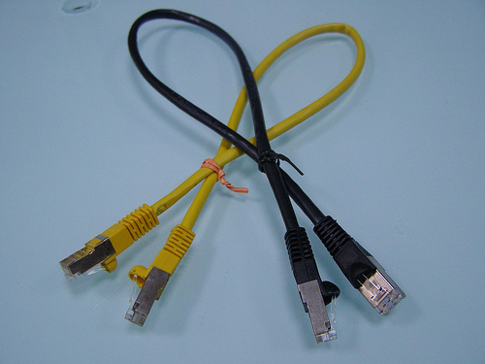
About Dax Networks
Part of Apcom Group, Dax Networks is one of the top three networking companies in India. Dax currently offers end-to-end networking solutions to the Government, Telecom, ISP, Financial Services, Education, Defence, and Corporate segments, among others.
Today, Dax has the widest array of networking products available in India, meeting the “edge to core” needs of all given vertical segments.
For further details, please contact:
Mayura K,
Dax Networks Limited
Ph: 044 – 24323558/7
Email: mayura@daxnetworks.com
Annapoorna K,
20:20 MEDIA
Tel: 91-44-28260145/ 9884203654
Email: annapoorna@2020india.com

